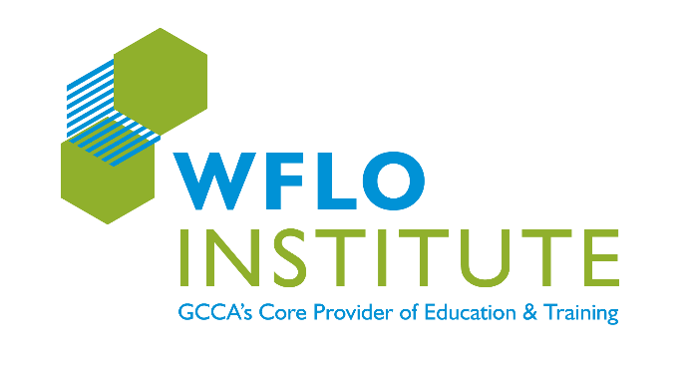

Anthony M. Leo WFLO Scholarship​ Fund

This year, the Global Cold Chain Alliance (GCCA) and RLS Logistics are pleased to announce the Anthony M. Leo WFLO Scholarship​ Fund. Before his passing in March 2021, Tony was a highly engaged member of the association serving as Treasurer of the Board, participating on numerous committees, presenting at events and a passionate advocate for training and educating the next generation of future cold chain leaders.

In honor of all he did for the association and the industry, the Anthony M. Leo WFLO Scholarship​ Fund
was created to provide a scholarship to a third-party cold chain logistics industry employee to attend the WFLO Institute for each of the three years of the program. One scholarship recipient will be chosen each year by a group of Tony’s industry colleagues. In 2022, RLS Logistics will make contributions to allow for a second individual to be awarded the Anthony M Leo Scholarship.

DONATE NOW TO HELP FUND THE ANTONY M. LEO SCHOLARSHIP PROGRAM

Levels of Contribution:
$2,500 $1,000 $500 $250 $100 $Other _________

I would like to pay by credit card (a GCCA staff member will contact you)
I would like to pay be check (please submit a check payable to the World Food Logistics Organization (WFLO), a 501(c)3 and mail check to: GCCA, 241 18th Street South Suite 620, Arlington, Virginia 22202.

Name:____________________________________ Title:_________________________________

Company:_______________________________________________________________________

Address: ________________________________________________________________________

City: ______________________________State/Province: _____________________Zip:________

Phone Number: (_____)________________E-mail:______________________________________

Signature: _______________________________________________________________________

Please submit this form to email@gcca.org

