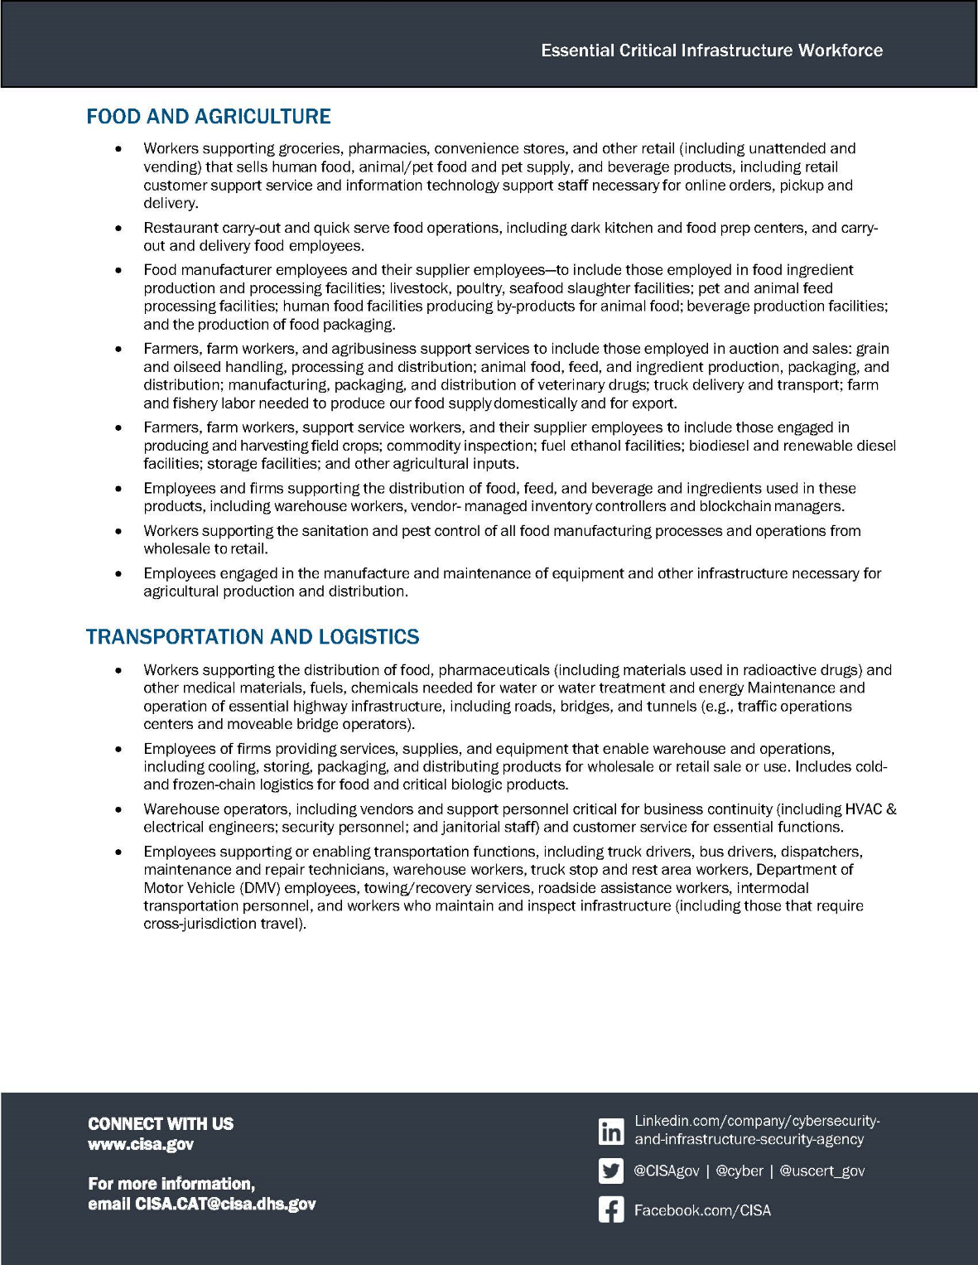
INSERT COMPANY LOGO

PHOTO

FIRST NAME LAST NAME
Company Name
Facility Address Line 1
Facility City, State Zip
United States
Designated Essential Critical Infrastructure Worker by U.S. Department of Homeland Security CISA
Frontline Workers in Food and Agriculture and Transportation and Logistics have been categorized as Essential Workers by the U.S. Centers for Disease Control for purposes of vaccine prioritization

