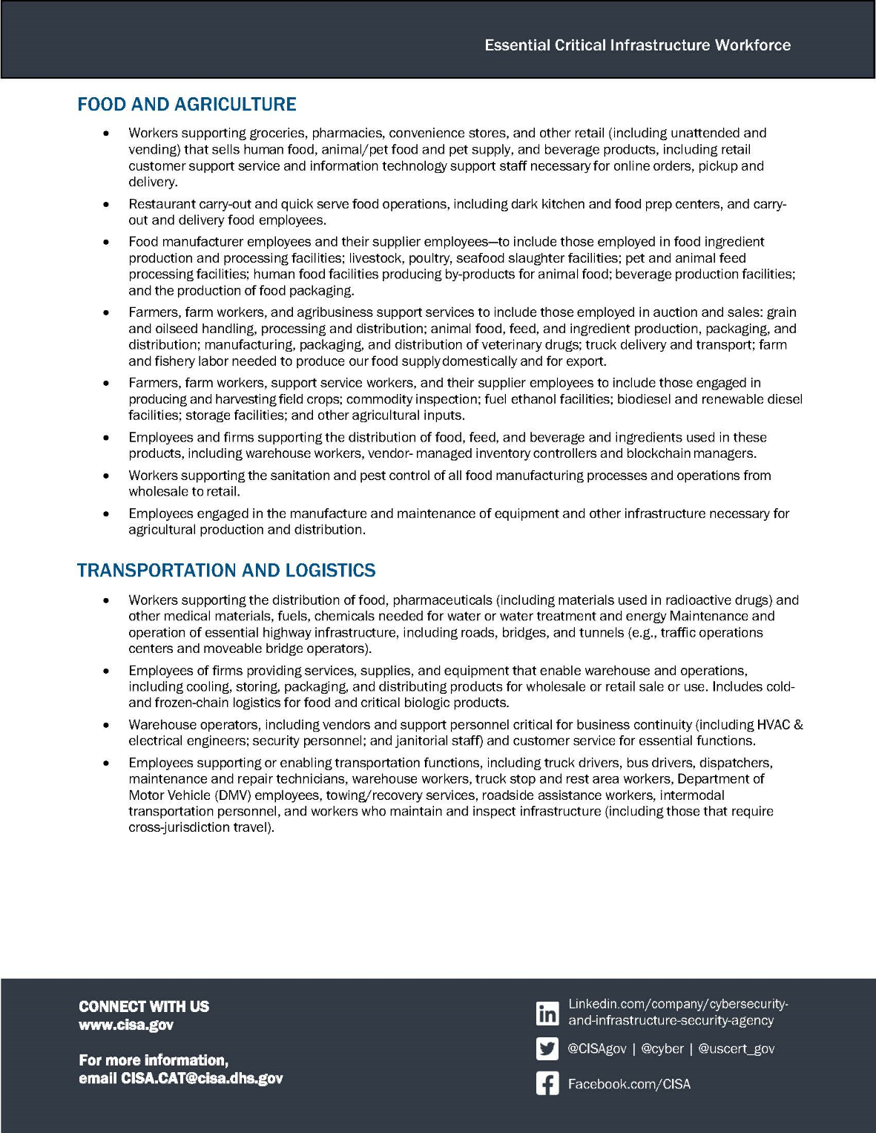
INSERT COMPANY LOGO

PHOTO

FIRST NAME LAST NAME
Company Name
Facility Address Line 1
Facility City, State Zip
United States
Designated Essential Critical Infrastructure Worker by U.S. Department of Homeland Security CISA

